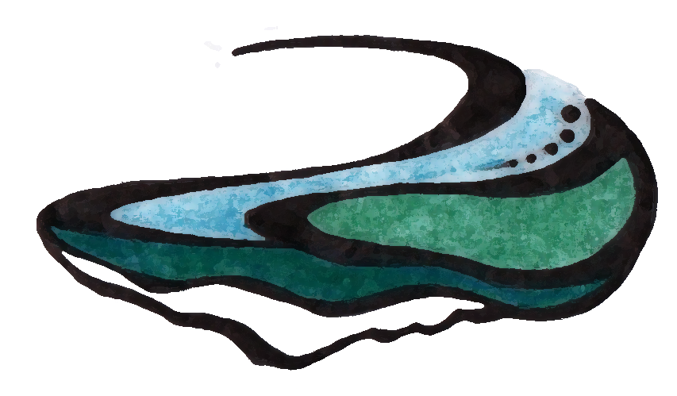
Luke Boyer, DC
Chiropractic Physician
Complementary Sports Medicine

HIPAA Form
Consent for Purposes of Treatment, Payment &
Healthcare Operations
In this document, “I” and “my” refer to the patient, and “Chiropractor” refers to Dr. Luke Boyer or Boyer
Chiropractic.

I consent to the use or disclosure of my protected health information by the Chiropractor for the purpose
of analyzing, diagnosing or providing treatment to me, obtaining payment for my health care bills or to conduct health care operations of the Chiropractor. I understand that analysis, diagnosis or treatment of me by the Chiropractor may be conditioned upon my consent as evidenced by my signature below.

I understand that I have the right to request a restriction as to how my protected health information is
used or disclosed to carry out treatment, payment or healthcare operations of the practice. The
Chiropractor is not required to agree to the restrictions that I may request. However, if the Chiropractor agrees to a restriction that I request, the restriction is binding on the Chiropractor.

I have the right to revoke this consent, in writing, at any time, except that the Chiropractor has taken
action in reliance on this Consent.

My “protected health information” means health information, including my demographic information,
collected from me and created or received by my physician, another health care provider, a health plan, my employer or a health care clearinghouse. The protected health information relates to my past, present or future physical or mental health or condition and identifies me, or there is a reasonable basis to believe the information may identify me.

I have been provided with a copy of the Notice of Privacy Practices of the Chiropractor and understand
that I have a right to review the Notice of Privacy Practices prior to signing this document. The Notice of Privacy Practices describes the types of uses and disclosures of my protected health information that will occur in my treatment, payment of my bills or in the performance of health care operations of the Chiropractor. This Notice of Privacy Practices also describes my rights and duties of the Chiropractor with respect to my protected health information.

The Chiropractor reserves the right to change the privacy practices that are described in the Notice of
Privacy Practices. I may obtain a revised notice of privacy practices by calling the office of the Chiropractor and requesting a revised copy be sent in the mail or asking for one at the time of my next appointment.

____________________________________________ ______________________________________
Signature of Patient or Personal Representative Printed Name of Patient

____________________________________________ ______________________________________
Date of Signing Description of Personal Representative’s Authority

